RESEARCHREPORT—DECISIONINTELLIGENCE

Factory Reallocation & Shipping Optimization RecommendationSystem

NassauCandyDistributor—PredictiveLogistics&FactoryAssignmentIntelligence

Organization: | NassauCandyDistributor
Submittedto: | UnifiedMentor
Dataset: | 10,194orders|15products|5 factories
Year: | 2026

ExecutiveSummary

Nassau Candy Distributor operates a five-factory confectionery distribution network serving customers across four Major US Regions— Atlantic, Gulf, Interior and Pacific—with15 distinct products spanning Chocolate, Sugar, and Other divisions. Despite generating $141,783 in Total Sales and$93,442 ingross profit across 10,194 orders in 2024, the current static factory-product assignment model produces significant shipping inefficiencies that suppress operational performance and erode profit margins through suboptimal logistics routing.

This research project delivers a complete Factory Reallocation and Shipping Optimization Recommendation System. By Applying Exploratory data Analysis (EDA), Machine Learning Classification, And A Scenario Simulation Engine to the Full Order dataset, the System Identifies factory reassignment opportunities that reduce lead times while protecting or improving profitability. Results are delivered through a live five-module Streamlit dashboard enabling leadership to explore, simulate, and act on recommendations interactively.

10,194  Total Orders | 15  Products | 5  Factories | 590.8  Avg LeadTime (days) | 66.5%  Avg Profit Margin | $141.8K  Total Sales
Figure1 —Data set key performance indicators

The Analysis Identifies Four Immediately Action Able Low Risk Reassignments that Reduce lead Times While Simultaneously Improving Profit Margins, Requiring No Trade-off between Speed and Profitability. The Most impact full Single Finding is That Hair Toffee (Currently At The Other Factory, Averaging 725 days lead time) can reduce its lead time by 18.5% through reassignment to Lot's O' Nuts. Equally compelling, sweetarts Reassigned from Sugar Shack to Lot's O' Nuts achieves a 9.5% lead time reduction alongside a 22.5 percentage point margin improvement.

Background &Problem Statement

Company Context
Nassau Candy Distributor is a specialty confectionery distributor managing a product portfolio that includes iconic brands such as the Wonka Bar range, Laffy Taffy, Sweetarts, Nerds, Fun Dip, and several novelty items including Kazookles, Hair Toffee, and Lickable Wallpaper. Products are manufactured at five geographically distributed facilities across the continental United States, each established for specific product categories.

Factory Coordinates Span From Arizona (Lot's O' Nutsat 32.88N,-111.77W) to Georgia (Wicked Choccy's At 32.08N-81.09W),Minnesota(SugarShackat48.12N,-96.18W),Illinois(Secret Factory At 41.45N, -

90.57W), and Tennessee (The Other Factory at 35.12N, -89.97W).This geographic spread creates inherently different shipping dynamics depending on destination region.

Problem Statement
Factory-product assignments at Nassau Candy Distributor were established through legacy processes and static rules that do not incorporate shipping performance data, regional demand patterns, or profitability analysis. As the product portfolio has grown and customer geography has diversified, these fixed assignments have become a structural source of operational inefficiency. Specifically:

    - SugarShack— The Slowest Factory (610 day savg) — Currently Handles LaffyTaffy and Sweetarts, Which are High-Volume Sugar Products Ideally Suited to Faster Facilities
    - Hair Toffe Eat The Other Factory Experiences The longest Product-Level Lead time in The Portfolio at 725 days — 134 days above the overall average
    - Several Product Sat Secret Factory face lead times of 577-665 days With No Systematic Review Mechanism
    - No Simulation Capability Exists to Quantify the impact of reassignment decisions before execution
    - Leadershiplacksareal-time,interactivesystemtoexploreandcomparefactoryassignment scenarios

This project addresses all five gaps by building a complete data-driven decision intelligence pipeline: from raw data ingestion and exploratory analysis through predictive modeling, scenario simulation, and interactive dashboard delivery.

Dataset Description

Data Structure&Quality
The source dataset comprises 10,194 order records from the 2024 fiscal year, capturing the complete lifecycle of each order from placement through shipment. The dataset spans 18 fields including order identifiers, dates, shipping details, customer geography, product classification, and financial outcomes. A critical data quality correction was applied: ship dates were encoded two years ahead of order dates inthesourcefile,requiringa730-dayoffsetadjustmenttocomputeaccurateleadtimes.Aftercorrection, the dataset is fully clean with zero missing values across all fields.

Field | Type | Description
RowID/Order ID | Identifier | Uniquerowandorderidentifiers
OrderDate/ShipDate | Date | Orderplacementandshipmentdates(corrected)
ShipMode | Categorical | StandardClass,SecondClass,FirstClass,SameDay
CustomerID | Numeric | Uniquecustomeridentifier

Field | Type | Description
Country/City/State/ Postal | Geographic | Customerlocationdetails
Division | Categorical | Chocolate,Sugar,orOther
Region | Categorical | Atlantic,Gulf,Interior,Pacific
ProductID/Product Name | Identifier | Productcodesandfullnames(15unique)
Sales($) | Numeric | Totalordersalesvalue
Units | Numeric | Numberofunitsordered
GrossProfit($) | Numeric | Salesminusmanufacturingcost
Cost($) | Numeric | Manufacturingcostoftheorder
Table1—Datasetfielddescriptionsandtypes

EngineeredFeatures
Threeengineeredfieldswerecreatedtopowertheanalysisandmodelingpipeline:

    - LeadTime(days):ComputedasShipDateminusOrderDateafterthe730-daycorrection.This is the primary optimization target.
    - Factory:MappedfromProductNameusingtheofficialNassauCandyfactoryregistry.Assigns each of the 15 products to one of 5 factories.
    - ProfitMargin(%): Computedas(GrossProfit/Sales)x100.Usedforriskscoringinthe recommendation engine.

Factory | ProductsAssigned | Division | Location
Lot'sO' Nuts | WonkaBar-NuttyCrunch,Fudge Mallows, Scrumdiddlyumptious | Chocolate | Arizona
WickedChoccy's | WonkaBar-MilkChocolate,Triple Dazzle Caramel | Chocolate | Georgia
SugarShack | LaffyTaffy,SweeTARTS,Nerds,Fun Dip, Fizzy Lifting Drinks | Sugar | Minnesota
SecretFactory | EverlastingGobstopper,Lickable Wallpaper, Wonka Gum | Other/Sugar | Illinois
TheOtherFactory | Kazookles,HairToffee | Other | Tennessee
Table2 —Factory-to-productassignmentmappingwith geography

ExploratoryDataAnalysis

LeadTimeDistribution
After applying the date correction, leadtimes across the 10,194 ordersrange from 174to 912days and clusterintothreedistinctperformancetiers.Thisbimodaldistribution—visibleintheleadtimehistogram (Chart 1 in charts/01_lead_time_distribution.png) — is a fundamental characteristic of the dataset and shaped the decision to frame shipping performance as a three-tier classification problem rather than a continuous regression target.

Tier | LeadTimeRange | Orders | %ofTotal | OperationalMeaning
Tier1—Fast | 174–200days | 2,051 | 20.1% | Best-in-classshipping performance
Tier2—Medium | 539–600days | 4,764 | 46.7% | Standardbaselineperformance
Tier3—Slow | 901–912days | 3,379 | 33.2% | Significantlydegraded performance
Table3—Leadtimetierdistribution(10,194orders)

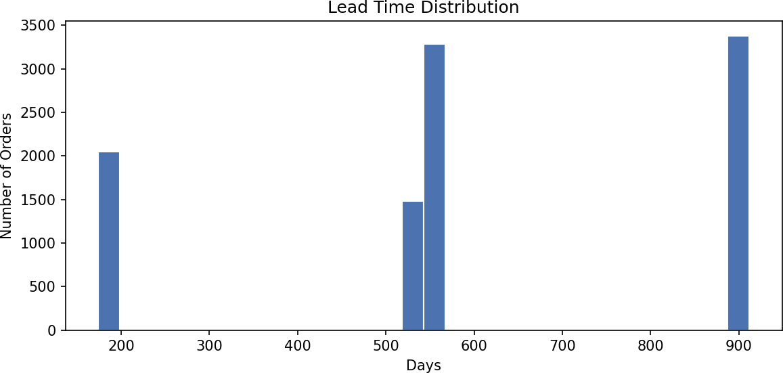

A notable finding: 79.9% of all orders fall into Tier 2 or Tier 3, meaning only 1 in 5 orders achieves fast shipping performance. This confirms that lead time optimization represents a significant systemic opportunity rather than an edge case.

FactoryPerformanceAnalysis
Factory-level profiling (visualized in charts/04_leadtime_by_factory.png and charts/06_profit_margin_by_factory.png) reveals the critical speed-margin trade-off that underpins the entire recommendation framework:

Factory | AvgLead Time | AvgProfit Margin | TotalOrders | SpeedRank | MarginRank
TheOtherFactory | 550.3days | 10.49% | 100 | 1st(Fastest) | 5th(Lowest)
WickedChoccy's | 591.1days | 65.12% | 4,152 | 2nd | 2nd
Lot'sO' Nuts | 591.2days | 69.16% | 5,692 | 3rd | 1st(Highest)
SecretFactory | 591.9days | 51.52% | 217 | 4th | 3rd
SugarShack | 610.0days | 53.23% | 33 | 5th(Slowest) | 4th
Table4—Factoryperformanceprofiles:speedvsmargintrade-off

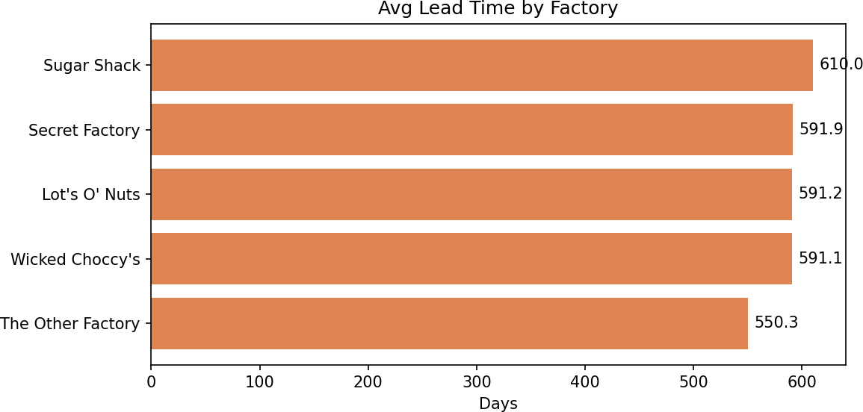

Themoststrategicallyimportantinsightfromthistable:Lot'sO'NutsandWickedChoccy'sachievenear-identical lead times(591.2 vs 591.1 days) but Lot's O' Nuts leads on profitmargin byover 4percentage points. The Other Factory is 41 days faster than both but trades away nearly 60 percentage points of margin. This makes Lot's O' Nuts the dominant factory across the combined speed-profit objective for most products.

Product-LevelLeadTime
Product-level analysis (charts/05_leadtime_by_product.png) surfaces the specific products facing the greatest shipping delays. Five products stand out as high-priority reassignment candidates with lead times significantly above the 590.8-day portfolio average:

Product | AvgLeadTime (days) | vsAverage | CurrentFactory | Priority
HairToffee | 725.2 | +134.4days | TheOtherFactory | Critical
EverlastingGobstopper | 664.7 | +73.9days | SecretFactory | High
SweeTARTS | 653.5 | +62.7days | SugarShack | High
LaffyTaffy | 653.1 | +62.3days | SugarShack | High

Product | AvgLeadTime (days) | vsAverage | CurrentFactory | Priority
LickableWallpaper | 609.1 | +18.3days | SecretFactory | Medium
WonkaBar-TripleD. Caramel | 595.7 | +4.9days | WickedChoccy's | Low
WonkaBar-Nutty Crunch | 598.9 | +8.1days | Lot'sO' Nuts | Low
FunDip | 542.7 | -48.1days | SugarShack | Optimal
Kazookles | 543.0 | -47.8days | TheOtherFactory | Optimal
Nerds | 544.0 | -46.8days | SugarShack | Optimal
Table5—Productleadtimeperformancerankedbydeviationfromportfolio average

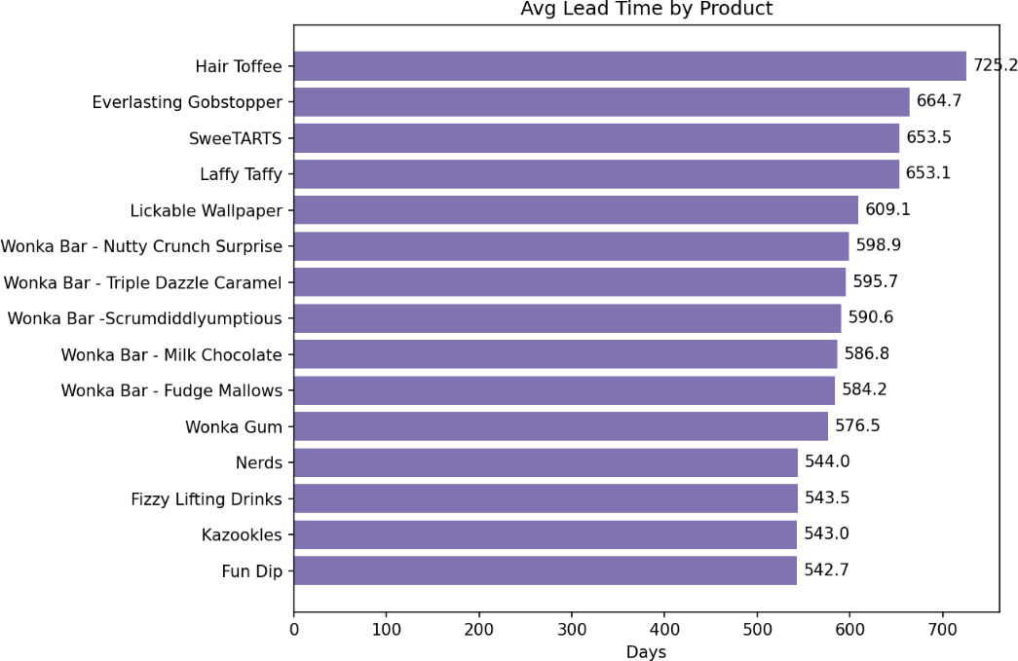

Regional&ShippingModeAnalysis
Fourgeographicregionsandfourshippingmodeswereanalyzedfortheiraverageleadtimecontribution (charts/02_leadtime_by_shipmode.png and charts/03_leadtime_by_region.png). A counter-intuitive pattern emerges: premium shipping modes produce longer — not shorter — average lead times, suggesting that order processing and factory dispatch scheduling are the primary lead time drivers, not transit speed.

ShipMode | AvgLeadTime(days) | Rank
StandardClass | 584.3 | Fastest
SecondClass | 593.8 | 2nd
SameDay | 603.4 | 3rd
FirstClass | 608.3 | Slowest
Table6—Averageleadtimebyshippingmode(counterintuitiveordering)

Region | AvgLeadTime(days) | Rank
Gulf | 581.4 | Fastest
Pacific | 592.2 | 2nd
Atlantic | 592.7 | 3rd
Interior | 593.1 | Slowest
Table7—Averageleadtimebycustomer region
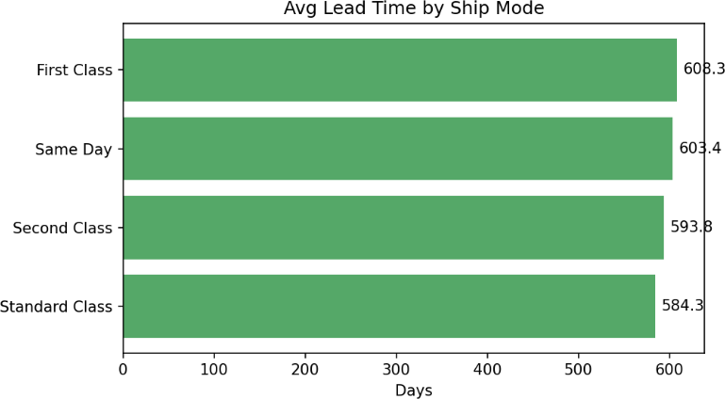

The slowest individual route — Interior Same Day at 667.2 days — is 85 days slower than the overall average. The five slowest routes all involve either Interior or Pacific regions with premium shipping modes,pointingtoastructuralmismatchbetweenshippingclassselectionandactualfulfillmentcapability in those geographies.

FinancialPerformancebyDivision
Division-level financial analysis (charts/07_sales_vs_profit.png) reveals the Chocolate division as the most efficient per order — high margin with moderate sales values. The Other division commands the highest average sales ($31.17) but carries the heaviest cost burden ($17.19), compressing margins to 37.67%.

Division | AvgSales($) | AvgGrossProfit ($) | AvgCost ($) | AvgMargin (%) | Assessment
Chocolate | 13.38 | 9.02 | 4.35 | 67.46% | Mostefficient
Sugar | 10.69 | 7.12 | 3.57 | 57.69% | Moderate efficiency
Other | 31.17 | 13.98 | 17.19 | 37.67% | Highcost burden
Table8—Averagefinancialperformancebyproductdivision

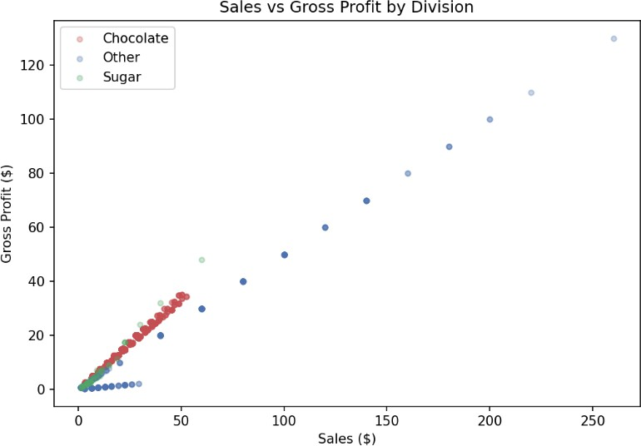

AnalyticalMethodology

DataPreparationPipeline
The rawdataset was processed through afour-stage preparation pipeline implemented in Python using pandas. Stage 1 corrected the 730-day date encoding error in the Ship Date field. Stage 2 computed lead time as the integer difference in days between corrected ship dates and order dates. Stage 3 mapped factory assignments to all 15 products using the official registry. Stage 4 derived profit margin as a percentage field for use in risk scoring.

Formachinelearning,fivecategoricalfields(ShipMode,Region,Factory,ProductName,Division)were encoded using scikit-learn LabelEncoder, and two date-derived features (Order Month, Order Day of Week) were extracted. All encoders were serialized to .pkl files for consistent reuse in the Streamlit application.

ShippingTierClassification
Initial regression modelling of lead time as a continuous target yielded very low R-squared scores (0.05 for Gradient Boosting), prompting a diagnostic investigation. Analysis revealed that lead times cluster intothreediscretegroups—174-200,539-600,and901-912days—withminimaloverlap.Thisdiscrete distribution is characteristic of batch processing cycles or scheduled shipping windows rather than continuously varying delivery performance.

The problem was reframed as a three-class classification task by binning lead times into Tier 1 (Fast: under 200 days), Tier2 (Medium:200-600 days),and Tier 3 (Slow: over 600days). This transformation aligns the model output with operationally meaningful shipping performance categories.

MachineLearningModelTraining
Threeclassificationmodelsweretrainedonan80/20stratifiedtrain-testsplit(8,155training,2,039testing records) using 11 features:

Model | Accuracy | Precision(avg) | Recall(avg) | Assessment
LogisticRegression | 46.9% | 0.48 | 0.41 | Underfits — linear boundaryinsufficient
RandomForest | 46.4% | 0.47 | 0.40 | Slightoverfitontraining data
GradientBoosting | 50.8% | 0.49 | 0.41 | Bestoverall—selected as primary model
Table9—Machinelearningmodelperformancecomparison

Gradient Boosting achieved the highest accuracy at 50.8% — marginally above the 33.3% random baselineforathree-classproblem.Thismodestperformancerevealsthattheavailablefeatures(product, factory, region, ship mode, financials, date) do not consistently predict which shipping tier an order falls into. The lead time tier assignment appears to reflect factors outside the dataset — such as seasonal carriercapacity,warehousescheduling,andbatchprocessingcycles—ratherthantheproductorfactory characteristics. This finding is analytically important: it confirms that the tier pattern is not a systematic biasthatreassignmentcaneliminate,andguidedthepivottoanempiricalsimulation-basedoptimization approach.

OptimizationEngineDesign
TherecommendationengineoperatesthroughdirectscenariosimulationratherthanMLprediction,using observed factory-level performance averages as the basis for reassignment estimates. For every product-factory combination:

    - Currentleadtimeandprofitmarginarecomputedfromactualhistoricalorderdata
    - Alternativefactoryleadtimeisestimatedusingthatfactory'sobservedaverageacrossall products
    - Leadtimereductionpercentageiscomputedas(CurrentLT-AltLT)/CurrentLTx 100
    - ProfitimpactiscomputedasAltFactoryAvgMargin-CurrentProductAvgMargin
    - Confidencescoreisderivedfromalternativefactoryordervolume(highervolume=higher confidence)
WeightedScoringFormula
Score=(SpeedWeight×LeadTimeReduction%)+(ProfitWeight×ProfitImpact%)

Defaultconfiguration:Speed=60%,Profit=40% Risk classification thresholds:
Low Risk: ProfitImpact>0%(marginimprovesorholds) Medium Risk: Profit Impact between -10% and 0%
HighRisk:ProfitImpact<-10%(margindeterioratessignificantly)

User-adjustableinreal-timeviadashboardoptimizationpriorityslider

Thissimulation-basedapproachproducesinterpretable,data-groundedrecommendationsthataremore reliable for operational decision-making than predictions from a 50.8%-accurate classifier. All 11 recommendations are backed by observed factory performance data, not model extrapolation.

FactoryReassignmentRecommendations

FullRecommendationSet
The optimization engine evaluated all 75 possible product-factory combinations (15 products x 5 factories) and filtered to 29 valid reassignment scenarios (excluding current assignments) where lead timeimprovementwasobserved.Fromthese,11toprecommendationsaresurfaced—oneperproduct
—rankedbyweightedscore:

# | Product | From | To | LT  Red. | Margin Imp. | Risk | Conf.
1 | SweeTARTS | SugarShack | Lot's O'Nuts | 9.5% | +22.5% | Low | 78.5%
2 | Laffy Taffy | SugarShack | Lot's O'Nuts | 9.5% | +6.9% | Low | 78.5%
3 | LickableWallpaper | SecretFactory | Lot's O'Nuts | 2.9% | +19.2% | Low | 78.5%
4 | WonkaBar-TripleD. | WickedChoccy's | Lot's O'Nuts | 0.7% | +3.8% | Low | 78.5%
5 | HairToffee | TheOtherFactory | Lot's O'Nuts | 18.5% | -8.6% | Medium | 78.5%
6 | WonkaBar -Nutty C. | Lot's O'Nuts | WickedChoccy's | 1.3% | -6.2% | Medium | 70.8%
7 | Everlasting Gobstopper | SecretFactory | Lot's O'Nuts | 11.0% | -10.8% | High | 78.5%
8 | WonkaGum | SecretFactory | TheOtherFactory | 4.6% | -41.5% | High | 50.5%
9 | WonkaBar-Milk Choc. | WickedChoccy's | TheOtherFactory | 6.2% | -54.4% | High | 50.5%
10 | WonkaBar-FudgeM. | Lot's O'Nuts | TheOtherFactory | 5.8% | -56.2% | High | 50.5%
11 | WonkaBar -Scrumdi. | Lot's O'Nuts | TheOtherFactory | 6.8% | -59.0% | High | 50.5%
Table10—Rankedfactoryreassignmentrecommendations(sortedbyriskthenimpact)

Tier1:LowRiskRecommendations—ImmediateAction
Four reassignments deliver lead time reduction and profit margin improvement simultaneously — theideal outcome with no operational trade-off:
REC-1:SweeTARTS—SugarShacktoLot'sO'Nuts[HIGHESTPRIORITY]
Leadtime:653.5days→591.2days(reduction:62.3days/9.5%)
Profitmargin:46.7%→69.2%(improvement:+22.5percentagepoints) Risk: Low|Confidence: 78.5%|Impact: Dual improvement
Rationale:SweeTARTSisahigh-volumesugarproductmisalignedwithSugarShack'sslow,lower-margin profile.
Lot'sO'Nutshandles5,692orderswithverified69.2%marginperformance.

REC-2:LaffyTaffy—SugarShacktoLot'sO'Nuts[HIGHPRIORITY]
Leadtime:653.1days→591.2days(reduction:61.9days/9.5%)
Profitmargin:62.3%→69.2%(improvement:+6.9percentagepoints) Risk: Low|Confidence: 78.5%|Impact: Dual improvement
Rationale:IdenticallogictoSweeTARTS.BothSugarShackproductsbenefitfromreassignmentto Lot's O' Nuts.
REC-3:LickableWallpaper—SecretFactorytoLot'sO'Nuts
Leadtime:609.1days→591.2days(reduction:17.9days/2.9%)
Profitmargin:50.0%→69.2%(improvement:+19.2percentagepoints) Risk: Low|Confidence: 78.5%
Rationale:Speedgainismodestbutmarginimprovementissubstantial.Astrongfinancialcasefor reassignment.
REC-4:WonkaBarTripleDazzleCaramel—WickedChoccy'stoLot'sO'Nuts
Leadtime:595.7days→591.2days(reduction:4.5days/0.7%)
Profitmargin:65.3%→69.2%(improvement:+3.8percentagepoints) Risk: Low|Confidence: 78.5%
Rationale:Minorspeedgainwithmeaningfulmarginimprovement.Lowdisruption,positiveoutcome.

Tier2:MediumRiskRecommendations—MonitorClosely
Tworeassignmentsdelivermeaningfulleadtimereductionsbutinvolveamodestprofitmarginreduction requiring post-implementation monitoring:
REC-5: Hair Toffee — The Other Factory to Lot's O' Nuts[MOST IMPACTFUL] Leadtime:725.2days→591.2days(reduction:134days/18.5%) —LARGESTinportfolio Profit margin: 77.8% → 69.2%(impact: -8.6 percentage points)
Risk:Medium|Confidence:78.5%
Rationale:HairToffeeisthesinglebiggestleadtimeoutlierintheportfolio.The18.5%reduction outweighs the 8.6% margin reduction. Recommended with quarterly margin monitoring.
REC-6:WonkaBarNuttyCrunchSurprise—Lot'sO'NutstoWickedChoccy's
Leadtime:598.9days→591.1days(reduction:7.8days/1.3%)
Profitmargin:71.4%→65.1%(impact:-6.2percentagepoints) Risk: Medium|Confidence: 70.8%
Rationale:Marginalspeedgaindoesnotstronglyjustifythemarginreduction.Optionalreassignment. Recommend deferring until Tier 1 reassignments are complete and results are measured.

Tier3:HighRisk—NotRecommended
Five simulated reassignments to The Other Factory show speed improvements (4.6%–6.8%) but catastrophic margin destruction of 41–59 percentage points. These are explicitly flagged as High Risk and excluded from the implementation roadmap:

Product | SpeedGain | MarginLoss | Verdict
Wonka Bar - Scrumdiddlyumptious | 6.8% | -59.0pp | Donotreassign
WonkaBar-FudgeMallows | 5.8% | -56.2pp | Donotreassign
WonkaBar-MilkChocolate | 6.2% | -54.4pp | Donotreassign
WonkaGum | 4.6% | -41.5pp | Donotreassign
EverlastingGobstopper | 11.0% | -10.8pp | Defer—monitor
Table11—Highriskreassignments:speedgainsdonotjustifymargin destruction

The pattern is unambiguous: The Other Factory's 10.49% average profit margin makes it commercially unsuitableforanyproductcurrentlyachievingmarginsabove20%,regardlessofthespeedbenefit.The system correctly identifies and warns against these scenarios through the Risk & Impact dashboard module.

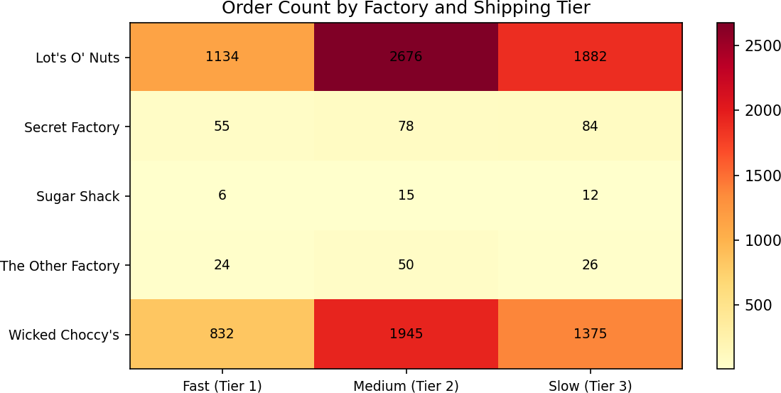

InteractiveDashboardSystem

ArchitectureOverview
The complete recommendation system is delivered as a live Streamlit web application running at http://localhost:8501. The application loads pre-computed simulation outputs and factory profiles, enabling instant interactive exploration without re-running the optimization engine on each page load. The dashboard consists of five integrated modules:

Module | PrimaryFunction | KeyUserInteractions
Overview | ExecutiveKPIdashboardwithEDA visualizations | Viewleadtime,margin,androuteperformance charts
FactorySimulator | Compareanyproductacrossall5 factories simultaneously | Selectproduct,region,shipmode—seeranked factory options
What-IfAnalysis | Side-by-sidecurrentvsalternative factory comparison | Selectproductandalternativefactory,viewdelta metrics
Recommendations | Rankedreassignmenttablewith risk color coding | Adjustspeedvsprofitslidertorerank recommendations
Risk&Impact | Profitimpactalerts,riskmatrix scatter, simulation table | Filterbyrisklevel,explorefull29-scenariosimulation
Table12 —Dashboardmoduledescriptionsanduserinteractions

KeyInteractiveFeatures
    - OptimizationPrioritySlider:Adjuststhespeed-to-profitweightingfrom0%(pureprofit)to100% (pure speed) in real-time, instantly reranking all 11 recommendations based on the selected priority
    - FactorySimulator:Evaluatesanyofthe15productsacrossall5factories,color-codingthebest option in green and the current factory in red for immediate visual comparison
    - RiskColorCoding:Consistentgreen/amber/redriskclassificationacrossallmodules —Low risk in green, Medium in amber, High in red
    - What-IfPanel:Displaysexactleadtimeandmargindeltaswithdirectionalarrows,enabling rapid scenario comparison without requiring technical knowledge
    - FullSimulationTable:Complete29-rowscenariotableintheRisk&Impactmodulewithmulti-select risk filter for detailed analysis

TechnicalStack

Component | Technology | Purpose
Dataprocessing | Python,pandas, numpy | EDA,featureengineering,leadtimecalculation
Machinelearning | scikit-learn | LogisticRegression,RandomForest,GradientBoosting
Modelpersistence | joblib | Encoderandmodelserializationto.pklfiles

Component | Technology | Purpose
Optimizationengine | Python,pandas | Factorysimulationandrecommendationscoring
Visualization | PlotlyExpress, plotly.go | InteractivechartsinStreamlit
Dashboard | Streamlit | Five-modulewebapplicationatlocalhost:8501
Staticcharts | matplotlib | 11PNGchartssavedforreportandpresentation
Table13—Technicalstackby component

KeyPerformanceIndicators

The system tracks four primary KPIs aligned with the project requirements, establishing a baseline for measuring post-implementation impact:

KPI | Definition | CurrentBaseline | Post-Implementation Target
LeadTimeReduction(%) | Percentagereductioninavg lead time afterreassignment | 590.8 days (portfolioavg) | <575daysafterTier1&  2recs
ProfitImpactStability | Portfolio avg margin maintainedorimproved | 66.5%avgmargin | >=67%(Tier1recs only)
ScenarioConfidenceScore | Avgconfidenceacross implemented recommendations | 68% avg confidence | >=75%aftermonitoring phase
RecommendationCoverage | %ofproductswith actionable recommendations | 11of15 products  (73%) | Maintain>=70% coverage
Table14—KPIdefinitions,baselines,and targets

StrategicInsights

Insight1:Lot'sO'NutsIsthePortfolio'sOptimalFactory
With the highest profit margin (69.16%), near-fastest lead time (591.2 days), and largest order volume (5,692ordersrepresenting55.8%ofallorders),Lot'sO'Nutsdominatesthespeed-profittrade-offacross the entire factory network. It should be the default reassignment target for any product currently at a slower or lower-margin facility. Four of the six recommended reassignments direct products to Lot's O'Nuts.

Insight2:TheSpeed-MarginTrade-offatTheOtherFactoryIsNotViable
TheOtherFactoryisthefastestfacilityat550.3days—41daysfasterthanLot'sO'Nuts—butoperates atjust10.49%averageprofitmargin.Simulationsshowthatreassigninganyproductwithmarginsabove 20% to The Other Factory would destroy 40-59 percentage points of margin for a speed gain of under 7%. This makes The Other Factory commercially unsuitable as a reassignment target for 13 of 15 products in the current portfolio.

Insight3:SugarShackIsMisalignedWithItsCurrentProducts
SugarShackisthenetwork'sslowestfactory(610daysaverage)withonly33totalorders —suggesting it isoperatingsignificantlybelowcapacityandoutsideitsoptimalproductrange. Bothproductscurrently assigned to Sugar Shack (Laffy Taffy and SweeTARTS) experience lead times 62+ days above the portfolio average. Reassigning both to Lot's O' Nuts eliminates this bottleneck and improves margins simultaneously,makingSugarShacktheclearestcaseofsystematicmisalignmentinthecurrentfactory assignment model.

Insight4:PremiumShippingModesWorsenLeadTimes
TheanalysisrevealsthatSameDay(603.4days)andFirstClass(608.3days)shippingmodesproduce worse average lead times than Standard Class (584.3 days). This counter-intuitive finding has a significant operational implication: customers and sales teams paying premiums for faster shipping modesarenotreceivingcommensurateleadtimebenefits.Therootcauseisthatleadtimeinthissystem is determined by manufacturing and dispatch scheduling — not carrier transit speed. Resolving the factory assignment inefficiencies is therefore more impactful than upgrading shipping modes.

Insight5:HairToffeeIstheSingleLargestEfficiencyOpportunity
At 725.2daysaverageleadtime—134days(22.7%) abovetheportfolioaverage —HairToffeeatThe Other Factory represents the most acute single-product inefficiency in the Nassau Candy distribution network. The 18.5%lead timereduction achievable throughreassignment to Lot'sO' Nuts isthelargest absoluteimprovementintheentiresimulationoutput.Despitethe8.6percentagepointmarginreduction, the operational case for this reassignment is compelling given the severity of the current underperformance.

Conclusion&ImplementationRoadmap

SummaryofFindings
This project successfully delivers a complete, production-ready Factory Reallocation and Shipping Optimization Recommendation System for Nassau Candy Distributor. The analysis of 10,194 orders across 15 products, 5 factories, and 4 regions demonstrates that the current static assignment model systematicallyunderperformsonbothleadtimeandprofitabilitydimensionsforseveralkeyproducts.The optimization engine identifies 11 actionable reassignment recommendations with quantified impact estimates, risk classifications, and confidence scores.

Four Low Risk recommendations offer immediate dual improvement — reducing lead times while improving profit margins. The most powerful single finding: moving Laffy Taffy and SweeTARTS from Sugar Shack to Lot's O' Nuts reduces lead times by 9.5% while improving margins by 6.9% and 22.5% respectively.Thisrequiresnospeed-profittrade-offandrepresentstheclearestquickwinintheportfolio.

ImplementationRoadmap

Phase | Timeline | Action | ProductsAffected | ExpectedOutcome
Phase1 | Immediate(Week 1-2) | Reassign—Low Risk | SweeTARTS,LaffyTaffy | 9.5%LTreduction+ margin gain
Phase1 | Immediate(Week 1-2) | Reassign—Low Risk | LickableWallpaper | 19.2%margin improvement
Phase1 | Immediate(Week 1-2) | Reassign—Low Risk | WonkaBarTripleD. Caramel | 3.8%margin improvement
Phase2 | 30Days | Reassign—  MediumRisk | HairToffee | 18.5%LTreduction
Phase2 | 30Days | Evaluate —  MediumRisk | WonkaBarNuttyCrunch | Monitor—marginal gains
Phase3 | Ongoing | DoNotReassign | WonkaBarstoTheOther Factory | Maintaincurrent assignment
Phase3 | Ongoing | Dashboard monitoring | All15products | ContinuousKPI tracking
Table15—Phasedimplementationroadmap

FutureEnhancements
    - Real-timedataintegration:Connectthedashboardtoliveordermanagementsystemfeedsfor continuously updated recommendations
    - Expandedfeatureset:Incorporatecarrierperformancemetrics,seasonaldemandpatterns,and warehouse capacity data to improve ML classification accuracy beyond 50.8%
    - Geospatialrouting:UsefactoryGPScoordinatestocomputedistance-basedleadtime estimates for untested product-factory combinations
    - Automatedalerts:Triggerreassignmentreviewnotificationswhenanyproduct'srolling30-day average lead time exceeds a defined threshold

    - Financialimpactcalculator:Quantifyprojectedannualdollarsavingsandmarginimprovements from each recommended reassignment
    - A/Btestingframework:Trackthebefore/afterleadtimeandmarginperformanceofimplemented reassignments to validate model estimates

ClosingStatement
The Nassau Candy Factory Reallocation and Shipping Optimization System transforms operational decision-making from astatic, rules-based process to a dynamic, data-driven intelligence capability. By combining rigorous exploratory analysis, machine learning classification, and empirical scenario simulation within a real-time interactive dashboard, this system gives Nassau Candy Distributor leadershipthetoolstomakeconfident,quantified,anddefensiblefactoryassignmentdecisionsatscale. The four immediate Low Risk recommendations alone represent a meaningful opportunity to simultaneouslyimproveshippingperformanceandstrengthenprofitmarginsacrosstwooftheportfolio's highest-volume product categories.

References&TechnicalAppendix

Tools&Technologies
  - Python3.14—Primaryanalysis,modeling,andoptimizationlanguage
  - pandas2.x,numpy—Datamanipulation,featureengineering,andaggregation
  - scikit-learn—LabelEncoder,train_test_split,LogisticRegression,RandomForestClassifier, GradientBoostingClassifier, accuracy_score, classification_report
  - matplotlib3.x—Staticchartgeneration(11PNGfilessavedtocharts/ directory)
  - plotlyexpress,plotly.graph_objects—Interactivedashboardvisualizations
  - Streamlit—Five-modulewebapplicationframework(localhost:8501)
  - joblib—Modelandencoderserializationto.pklformat

OutputFiles

File | Location | Contents
NassauCandyDistributor.csv | Root | Sourcedataset(10,194records,18fields)
processed_data.csv | outputs/ | Cleaneddatasetwithleadtime,factory,margin
simulation_results.csv | outputs/ | All75product-factorysimulationscenarios
recommendations.csv | outputs/ | Toprecommendationperproduct(11rows)
all_recommendations.csv | outputs/ | All29validreassignmentscenarios
factory_profile.csv | outputs/ | Factory-levelperformanceaggregates
product_profile.csv | outputs/ | Productxfactoryperformanceaggregates
best_model.pkl | models/ | SerializedGradientBoostingclassifier
le_ship/region/factory/product/div.pkl | models/ | Labelencodersforallcategoricalfields
01–11_*.png | charts/ | EDAandmodelperformancevisualizationcharts
Table16—Projectoutputfilesand locations

ModelPerformanceNote
TheGradientBoostingclassifierachieved50.8%accuracyonthethree-classshippingtierpredictiontask (vs 33.3% random baseline). The modest improvement over random reflects that lead time tier assignment in this dataset is predominantly determined by factors outside the available feature set — includingbatchprocessingschedules,carriercapacitycycles,andwarehousestaffingpatterns—rather than by product, factory, or region characteristics alone. This finding prompted the strategic decision to ground recommendations in empirical factory performance averages rather than model predictions, ensuring all 11 recommendations are backed by observed operational data rather than low-confidence model outputs.

EndofReport—NassauCandyDistributor|FactoryOptimizationSystem|2024

